ANALYSIS OF BLU-DROP
(Limitations & Future Enhancement)

Aditya Bisht
Dept. of Computer Science & Engineering
Graphic Era Hill University Bhimtal, India
adityabisht220111794@gmail.com

Abstract- Peer-to-peer (P2P) communication systems using Bluetooth and Wi-Fi Direct enable decentralized data exchange without infrastructure. However, flooding-based communication suffers from severe scalability limitations, including broadcast storms, excessive memory consumption, and high latency due to redundant message propagation. This paper presents a comprehensive analysis of these limitations and proposes a hierarchical clustering-based routing model combined with Bloom filter-based memory optimization. Analytical modeling and numerical evaluation demonstrate that the proposed approach reduces transmission complexity from O(N²) to near-linear behavior, hop count from linear to logarithmic growth, and memory usage by up to 60×. The results validate the effectiveness of structured communication and probabilistic data structures for large-scale decentralized networks.

I – Introduction

Peer-to-peer communication plays a critical role in applications such as disaster response, proximity-based sharing, and decentralized networking. Technologies such as Bluetooth Low Energy (BLE) and Wi-Fi Direct, integrated through APIs like Google Nearby Connections, enable direct communication between devices without centralized infrastructure.
Despite their advantages, these systems are primarily designed for small-scale deployments. As network size increases, flooding-based communication results in redundant message propagation, leading to broadcast storms, increased latency, high energy consumption, and excessive memory usage.
This paper addresses these challenges by:
• Analyzing limitations of flooding-based communication
• Proposing hierarchical clustering with routing optimization
• Introducing Bloom filter-based memory optimization
• Providing numerical and analytical validation of scalability improvements

II - System Model & Methodology

- Network Assumptions:
• Total number of devices in the network = N
• Average number of neighbouring nodes per node = k ≈ 4(based on P2P_CLUSTER constraints)
• Cluster size
= c ≈ 10 (design parameter)
• Number of clusters = N / c
- Performance Metrics:
• Total Transmissions (T)
• Hop Count (H)
• Memory Consumption (M)
- Evaluation Methodology:
• Analytical modeling of communication and memory complexity
• Numerical evaluation using scalable dataset
• Comparative analysis between flooding and proposed models

III - Existing Model: Flooding Algorithm

In the flooding-based model, each node rebroadcasts received messages to all its neighbors. While duplicate suppression prevents reprocessing, it does not eliminate redundant transmissions, resulting in excessive network overhead.

- Communication Complexity Approximation:

- Every device broadcast message to every neighbour device.
- N(Devices)*N(Transmission).
- P2P Cluster strategy provide 3-5 stable connections.
- Due to redundancy and over lapping of path the complexity remains O(N²).

T_flood = O(N²)

- Hop Count Complexity Approximation:
Three Possible Patterns of connections can be formed :
- Tree Like Structure: Connection of devices can be formed in a tree like structure which is ideal but very less probable to happen.
Properties of this structure:

  - One root node/device.
  - K – balanced tree ( k – Number of child node/connected devices )
H_tree = O(log_{k}N)

- Graph like Structure: Connection of devices form a graph like structure , there can be two possible formations.

  - Linear Chain : When devices form connection in a chain like formation , therefore hop count becomes linear .

H_chain = O(N)

  - Random Graph : When devices randomly connects to neighbour devices(3-5) .
This is the most probable case of connection in Blu_Drop.
Complexity Can not be correctly evaluated due to randomness

Approximation of complexity:
    - Each hop adds at least one new device from the neighbours.
    - Not all k neighbours are new devices added to network due to redundant path.
    - New devices added per hop is x*k. (x: is connectivity factor, x<=1)
    - Let H be number of hops required to deliver message to all the N devices.
So after H hops :
N ≈ x*k*h
H≈N/x*k
H≈O(N/k)

- Memory Complexity:

- Size of uuid is 128 bits =16 bytes ,
Converted to string due to:
  - Persistent storage prefers string based identifiers.
  - No need for serialization logic
  - No byte conversion
  - Direct storage and retrieval
- String consists of 36 characters:
  - 32 hex characters.
  - 4 hyphens.
  - String size = 36 bytes.
  - In Java/Kotlin character size is of 2 bytes.
- Size of string = 36*2 = 72 bytes
M_uuid = 72*N bytes
M_uuid=O(N)
Limitations:
• Broadcast Storm: Uncontrolled rebroadcasting leads to redundant transmissions and collisions
• Network Congestion: Increased traffic causes packet loss and delays
• High Latency: Unstructured propagation leads to large hop counts
• Memory Overhead: Linear growth in stored message identifiers
• Energy Consumption: Continuous forwarding drains battery resources
These limitations make flooding unsustainable for large-scale networks.

IV - Proposed Model: Hierarchical Clustering + Routing

The proposed model introduces hierarchical clustering combined with structured routing and memory optimization.
Architecture:
• Devices are grouped into clusters of size c
• Each cluster has a Cluster Head (CH)
• CHs form a higher-level communication network
Message Flow:
Device → Cluster Head → Cluster Network → Target Cluster → Device
- Communication Complexity:
The proposed hierarchical clustering model reduces communication complexity by dividing the network into smaller clusters.
Limiting global communication to cluster heads, the proposed model significantly reduces redundant transmissions compared to flooding-based approaches, enabling efficient scalability.
- Intra-cluster communication contributes O(N*c).
- Inter-cluster communication among cluster heads contributes O((N/c)²). The overall complexity is therefore given by T = Nc + (N/c)². By

T_total = Intra + Inter
T_total = N*c + (N/c)²
- Hop Count Complexity:

In the proposed hierarchical model, hop count is significantly reduced due to structured communication through cluster heads. The message first reaches the cluster head, is routed across cluster heads, and finally delivered to the destination node.

In the proposed hierarchical model, hop count is significantly reduced due to structured communication through cluster heads. The message first reaches the cluster head, is routed across cluster heads, and finally delivered to the destination node. Since the number of clusters is N/c, the inter-cluster hop count grows logarithmically. The total hop count is therefore given by H = 2 + log(N/c), resulting in efficient and scalable communication compared to flooding-based approaches.

- Sender_device to Sender’s Cluster Head. (Hop = log_{k} c)
- Number of clusters in Cluster Head Network = N/c.
- Routing avoids redundant paths so complexity will be logarithmic:
  - Number of CH neighbour , P2P Cluster supports 3-5 neighbours ( k)
  - Complexity = log_{k} (N/c) .
- Destination’s Cluster Head to Destination_device. (Hop = log_{k} c)

H_total = Intra + Inter + intra
H_total = 2 * log_{k} c + log_{k}(N/c)
H_total = log_{k} c² + log_{k}(N/c)
H_total = log_{k}(N/c * c²)
H_total = log_{k}(N * c )

- Memory Optimization:
A Bloom filter stores message identifiers using a compact bit array rather than explicitly storing each identifier. When a message is received, multiple hash functions are applied to its identifier, and the corresponding bit positions are set in the array. To check for duplicates, the same hash functions are applied, and the corresponding bits are examined. If all bits are set, the message is considered a probable duplicate; otherwise, it is treated as new. This approach significantly reduces memory usage while allowing efficient duplicate detection.
The memory requirement per element in a Bloom filter is given by c = -(ln p)/(ln 2)^2, where p represents the false positive probability. This formulation ensures optimal space efficiency while maintaining acceptable error rates.
72 byte per message uuid is reduced to approximately 1.2 bytes per element in bit array.
c = -(ln p)/(ln 2)^2 = 9.6 bits or 1.2 byte
M = N * c
M = O(N)

Advantages:
• Reduced global communication overhead
• Logarithmic hop count growth
• Significant memory reduction
• Improved scalability and efficiency

V – Results & Comparative Analysis

Devices (N) | Flooding_Transmissions (N^2) | Proposed_Transmissions (ceil) | Flooding_Hop (ceil N/4) | Proposed_Hop (ceil) | UUID_Memory (KB) | Bloom_Memory (KB)
100 | 10000 | 1100 | 25 | 5 | 7.03 | 0.12
200 | 40000 | 2400 | 50 | 6 | 14.06 | 0.23
300 | 90000 | 3900 | 75 | 6 | 21.09 | 0.35
400 | 160000 | 5600 | 100 | 6 | 28.12 | 0.47
500 | 250000 | 7500 | 125 | 7 | 35.16 | 0.59

The comparative analysis highlights significant improvements across all performance metrics.
Communication:
• Flooding: 1,000,000 transmissions (N = 1000)
• Proposed: 20,000 transmissions
• Improvement: ~50×
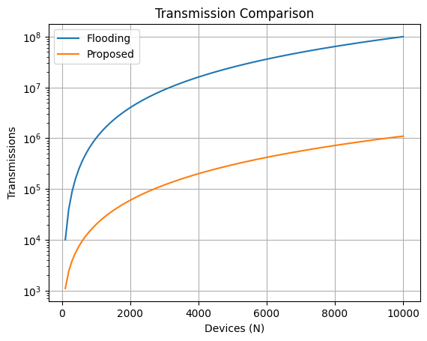

Latency (Hop Count):
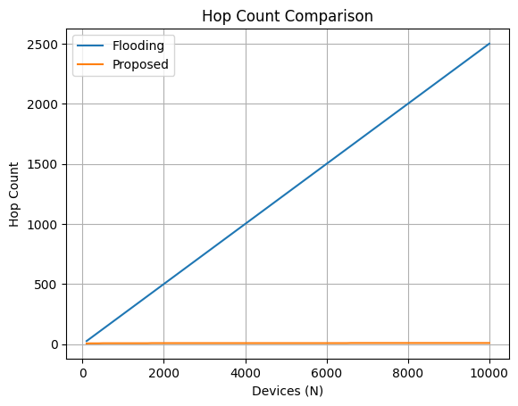
• Flooding: ~250 hops
• Proposed: ~5 hops
• Improvement: ~50×

Memory Usage:
• UUID Storage: 7.2 MB (100,000 messages)
• Bloom Filter: 120 KB
• Improvement: ~60×
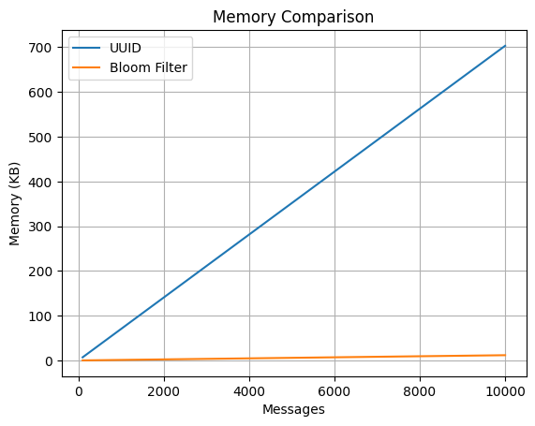
Observations:
• Flooding exhibits quadratic growth and poor scalability
• Proposed model maintains near-linear communication and logarithmic latency
• Memory optimization significantly reduces resource consumption
These results validate the effectiveness of the proposed approach for large-scale decentralized systems.

VI – Conclusion

This paper analyzed the limitations of flooding-based peer-to-peer communication systems and proposed a hierarchical clustering-based routing model combined with Bloom filter-based memory optimization. The results demonstrate significant improvements in communication efficiency, latency reduction, and memory utilization.
By transforming unstructured communication into a structured and scalable architecture, the proposed model enables efficient operation in large-scale networks. Future work may include dynamic cluster formation, adaptive routing strategies, and real-world deployment for performance validation.

References:

• S. Ni, Y. Tseng, Y. Chen, and J. Sheu, “The broadcast storm problem in a mobile ad hoc network,” Proceedings of the 5th ACM/IEEE International Conference on Mobile Computing and Networking (MobiCom), 1999, pp. 151–162.
• C. E. Perkins, E. M. Belding-Royer, and S. R. Das, “Ad hoc On-Demand Distance Vector (AODV) Routing,” RFC 3561, IETF, 2003.
• O. Younis and S. Fahmy, “HEED: A hybrid, energy-efficient, distributed clustering approach for ad hoc sensor networks,” IEEE Transactions on Mobile Computing, vol. 3, no. 4, pp. 366–379, 2004.
•Google, “Nearby Connections API”.
• Bluetooth SIG, “Bluetooth Core Specification v5.0,” 2016.
• A. Broder and M. Mitzenmacher, “Network applications of Bloom filters: A survey,” Internet Mathematics, vol. 1, no. 4, pp. 485–509, 2004.
• A. S. Tanenbaum and M. Van Steen, Distributed Systems: Principles and Paradigms, 2nd ed., Prentice Hall, 2007.

